Exercise – 5

1. Verify if master is in a clean state

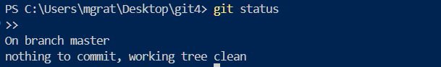

1. List out all the available branches

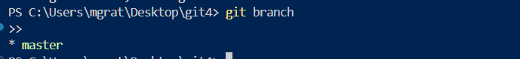

1. Pull the remote git repository to the master

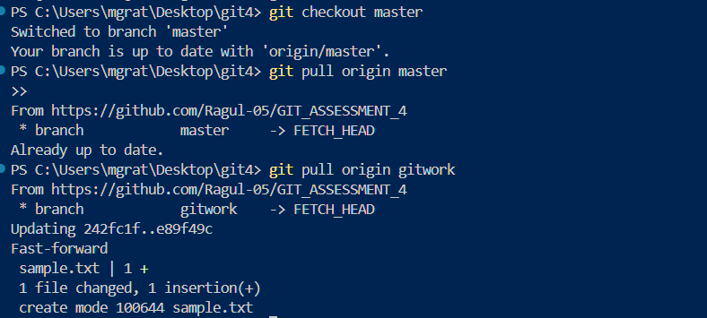

1. Push the changes (from previous lab) to the remote

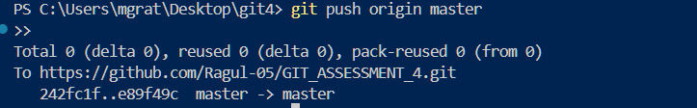

1. Confirm the changes on GitHub

